TOKYO INTERNATIONAL CORPORATION ON AFRICAN DEVELOPMENT (TICAD) MINI-CONSULTATIVE CONFERENCE HELD IN NAIROBI, KENYA ON SEPTEMBER 11TH 2018.
CONFERENCE REPORT
“Pulling Together in Preparation for TICAD VII’’
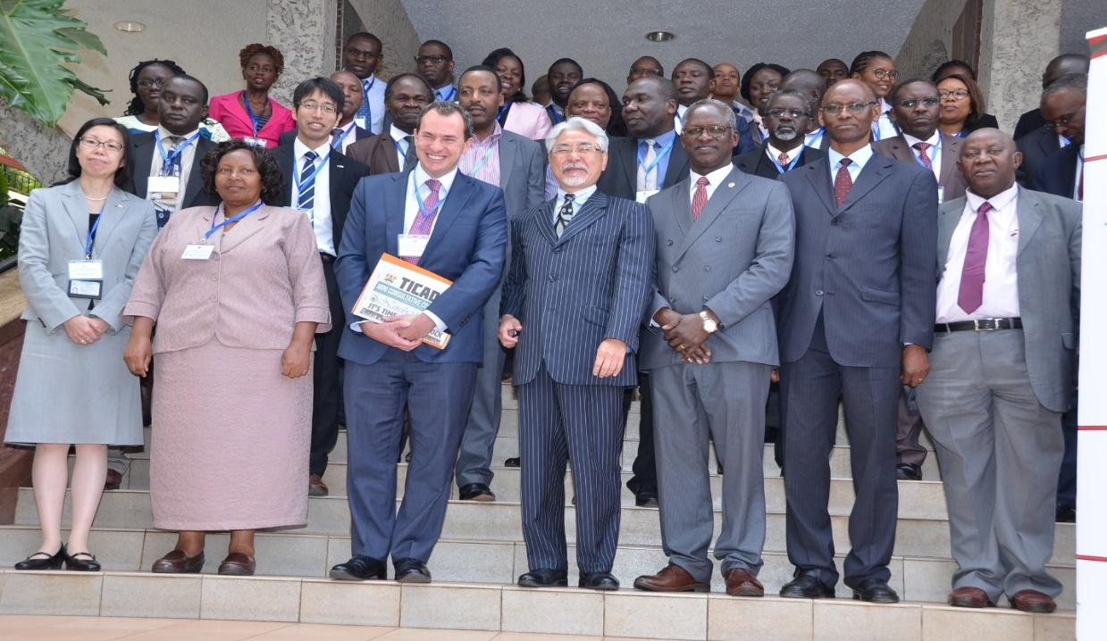
Photo 1: Participants Pose for a Group Photo

Venue:
The Panafric Hotel, Nairobi, Kenya
Date:
Tuesday 11th September, 2018

Contents

List of Photos 3
List of Tables 4
ACKNOWLEDGEMENT 5
EXECUTIVE SUMMARY 6
BACKGROUND 7
1.1 TICAD History 7
1.2 TICAD Mini-Consultative Conference 8
1.2.1 Aims and Objectives of the Sensitization Conference 9
1.2.2 Specific Theme and Focus 9
OPENING CEREMONY 10
2.1 Welcoming Remarks 10
2.2 Statements from Representatives of TICAD Co-organizers 13
2.2.1 UNDP 13
2.2.2 World Bank 16
2.2.3 African Union 17
2.2.4 The Government of Japan 19
2.2.5 Government of Kenya 21
STATUS OF TICAD IMPLEMENTATION 25
3.1 Sub-Theme 1: TICAD and Economic Growth 26
3.1.1 Trade 26
3.1.2 Water Sector 27
3.1.7 Plenary Session 1 30
3.2 Sub-Theme 2: TICAD and Agricultural Development 33
3.2.1 Health 34
3.2.3 Plenary Session 2 36
3.3 Sub-Theme 3: TICAD and Social Transformation 37
3.3.1 Blue Economy 37
3.3.2 Climate Change 38
3.3.3 Security 38
3.3.4 Transport 38
3.3.5 Plenary Session 3 39
3.4 TICAD and the Consolidation of the Private Sector 41
3.4.1 Japan External Trade Organization (JETRO) 41
3.4.2 Kenya Investment Authority (KenInvest) 42
3.4.3 Kenya Association of Manufacturers (KAM) 42
3.4.4 Kenya National Chamber of Commerce and Industry (KNCCI) 42
3.4.5 Plenary Session 4 43
EXPECTATIONS OF TICAD VII 45
SUMMARY OF THE DISCUSSIONS 51
CLOSING REMARKS 52
APPENDICES 55
1. Statements 55
2. Programme and Agenda 56
3. List of Delegates and Participants 58
1. Workshop Presentation and Handouts 61

List of Photos

Photo 1: Participants Pose for a Group Photo 0
Photo 2: Ambassador Ogutu Moderating the Session 12
Photo 3: Mr Maina making his presentation 13
Photo 4:Mr. Siddarth Chatterjee makes his opening statement 15
Photo 5: Mr Johannes Zutt making his opening statement 18
Photo 6: Dr. Mohamed Seisay Making his Statement 19
Photo 7: H.E Amb. Uesawa making his remarks 21
Photo 8:Mr. Joseph Mukui Giving Key Opening Remarks 23
Photo 9: Chief Guests Listen to the Proceedings during the Conference 27
Photo 10: Participants Keenly Follow Proceedings during the Conference 35
Photo 11: A Section of Participants Follow Proceedings during the Conference 41
Photo 12: Participants follow proceedings during the Conference 42
Photo 13: Mr Maina during his presentation 46
Photo 14:H.E Amb. Uesawa and Amb. Ogutu in a Consultative Moment on the Side-lines of the Conference 52
Photo 15: Ms. Keiko SANO, in a past event (Photo Courtesy of the Star News) 53
Photo 16: A section of Participants Follow Proceedings during the Conference 55

List of Tables

Table 1: TICAD Implementation Strategy 45

ACKNOWLEDGEMENTS

EXECUTIVE SUMMARY
______________________________________________________________________________
Following the successful hosting of the TICAD VI in Nairobi in August, 2016, the Japan International Cooperation Agency (JICA) and the State Department of Planning of the government of Kenya hosted a one Day National Stakeholders’ Sensitization Conference and Monitoring Workshop in preparation for the upcoming Tokyo International Conference on African Development (TICAD) VII. The Mini-Conference held on 11th September 2018 in Nairobi, Kenya at the Sarova Panafric Hotel was facilitated by the Institute for Development and Leadership in Africa (IDEA).
The conference explored the status of TICAD implementation across a number of sub-themes: TICAD and economic growth, TICAD and agricultural development, TICAD and social transformation, TICAD and the inclusive society agenda, and TICAD and consolidation of the private sector. In addition, the conference explored the role of TICAD in Kenya’s ‘BIG 4’ agenda and expectations of the upcoming TICAD VII.
This inaugural Mini-conference was attended by senior officials from the Government of Kenya led by the Economic Planning Secretary Mr Joseph Mukui who represented the Principal Secretary at the State Department of Planning Dr Joseph Muia and senior Officials from the Japan Embassy in Kenya led by the Japanese Ambassador to Kenya Mr Toshitsugu Uesawa. The TICAD co-organisers present included the United Nations (UN) Resident Coordinator and United Nations Development Programme (UNDP) Resident Representative, Mr Siddarth Chatterjee; World Bank Kenya Country Director Mr Johannes Zutt and the African Union Representative Mr Mohamed Seisay. Ms Keiko Sano, the Resident Representative of JICA in Kenya also led a team from JICA.
The Conference was facilitated by the Institute for Development and Leadership in Africa (IDEA) a Non-Governmental Organisation registered in Kenya since the year 2000 as an international think tank and capacity-building institution enhancing economic and leadership development in Kenya and in Africa.

BACKGROUND
__________________________________________________________________

TICAD History
When the Cold War ended, developed countries' interest in providing assistance to Africa began to wane. Under such circumstance, it was Japan that argued for the importance of Africa, and TICAD was the proof of Japan taking action. Nowadays, there are various fora through which many countries engage themselves with Africa, but TICAD launched by Japan was the forerunner of such fora for African development. Over the course of more than 20 years since TICAD I in 1993, the forum has a track record of improving social and economic conditions in Africa mainly through grant aids and technical assistance. In the five years starting from fiscal year 2008, the government of Japan built 1,321 elementary and middle schools, improved 4,778 healthcare and medical facilities, and provided safe water to additional 10.79 million people.
TICAD is a multilateral forum whose participants include not only African countries but also international organizations, partner countries, private companies and civil society organizations involved in development. The participants have been engaged in fruitful discussions on African development, bringing together a broad range of global knowhow and efforts of the international community. TICAD provides an open forum that generates innovative discussion, among various stakeholders, on African development.
Every meeting is led by Japan, and co-organised by the United Nations, United Nations Development Programme (UNDP), the World Bank and the African Union Commission (AUC). In principle, invitations to attend TICAD are extended to all African heads of state and government, as well as international organisations, donor countries, private companies and civil society organizations. Until TICAD V, the summit-level meetings were held every five years in Japan. From 2016 onwards, the TICAD will be held every three years, hosted alternately in Africa and Japan. In response to the request from the African side, we have decided to hold TICAD VI in Africa (Kenya).
TICAD has advocated the importance of African ownership and international partnership. Today, the development philosophy based on these two principles is shared globally. It has also inspired African countries, and it became the philosophical foundation of the New Partnership for Africa’s Development (NEPAD), the first comprehensive development plan created by Africans themselves.
In the TICAD process, Japan has established follow-up mechanisms. For example, pledges are announced at the summit-level meetings, and the status of their implementations is confirmed at the ministerial meetings. African countries have highly acclaimed the steady assistance extended by Japan, a country that keeps its promises.

TICAD Mini-Consultative Conference
As part of its mission and responsibility to promote and strengthen activities relating to the Tokyo International Conference on African Development (TICAD), JICA in collaboration with other national stakeholders; notably the Government of Kenya, found it fit to organize an event aimed at keeping TICAD activities in public focus and visibility.
The specific decision to hold the proposed conference and workshop was further informed by the previous and extremely successful hosting of TICAD VI in the City of Nairobi, Kenya in August 2016. This was the very first time a TICAD Summit was ever held in the continent of Africa.
TICAD VI was attended by, among others, the Prime Minister of Japan, H.E Shinzo Abe and President Uhuru Kenyatta of Kenya along with a contingent of business and Private sector leaders from Japan and Africa, including spouses and representatives of Civil Society Organizations (CSOs) and academia.
Considering that a Nairobi Declaration and Action Plan were signed and unanimously adopted at the conclusion of TICAD VI; and noting further that there was a Business Declaration by the Business Forum as well as ‘A Call to Action’ by the Spouses Forum. And moreover, realizing that that there are a number of activities relating to TICAD V and the Yokohama Declaration of 2013 that require constant follow-up.
Further, taking into account the need to strengthen the understanding and appreciation of TICAD by a larger segment of Kenya’s national stakeholders. And inspired by the need to strengthen the cordial relationship, friendship and mutually-beneficial co-operation between Japan, Kenya and Africa at large. Therefore in consideration, JICA met and held various meetings with the Institute of Development and Leadership in Africa (IDEA) as a strategic partner who could provide complimentary support in the aforesaid follow-up and delivery of TICAD-related programmes; including in the specific task of ensuring greater public understanding and appreciation of TICAD as well as of the Japan-Kenya relationship.

Aims and Objectives of the Sensitization Conference
The one day national sensitization conference had have three minimum objectives:
- To keep TICAD in visibility and focus: by bringing key national stakeholders together for information sharing and deeper understanding of the TICAD process especially its history; its intensions; delivery pillars and mechanisms, as well as the specific projects being undertaken.
- To provide and share current updates: Status reports from the various delivery sectors and progress made so far on implementing the Nairobi Declaration and Action Plan (2016)
- To adopt common positions: being part preparatory for TICAD VII scheduled for Tokyo in 2019.

Specific Theme and Focus
The conference was held under the running thematic focus spelt as follows: Pulling Together in Readiness for TICAD VII.

OPENING CEREMONY
__________________________________________________________________

Welcoming Remarks
The conference was brought to order by Dr. George Outa. He welcomed all the participants to the conference and highlighted the background and objectives as above, before welcoming Amb. Benson Ogutu who was moderating the session.
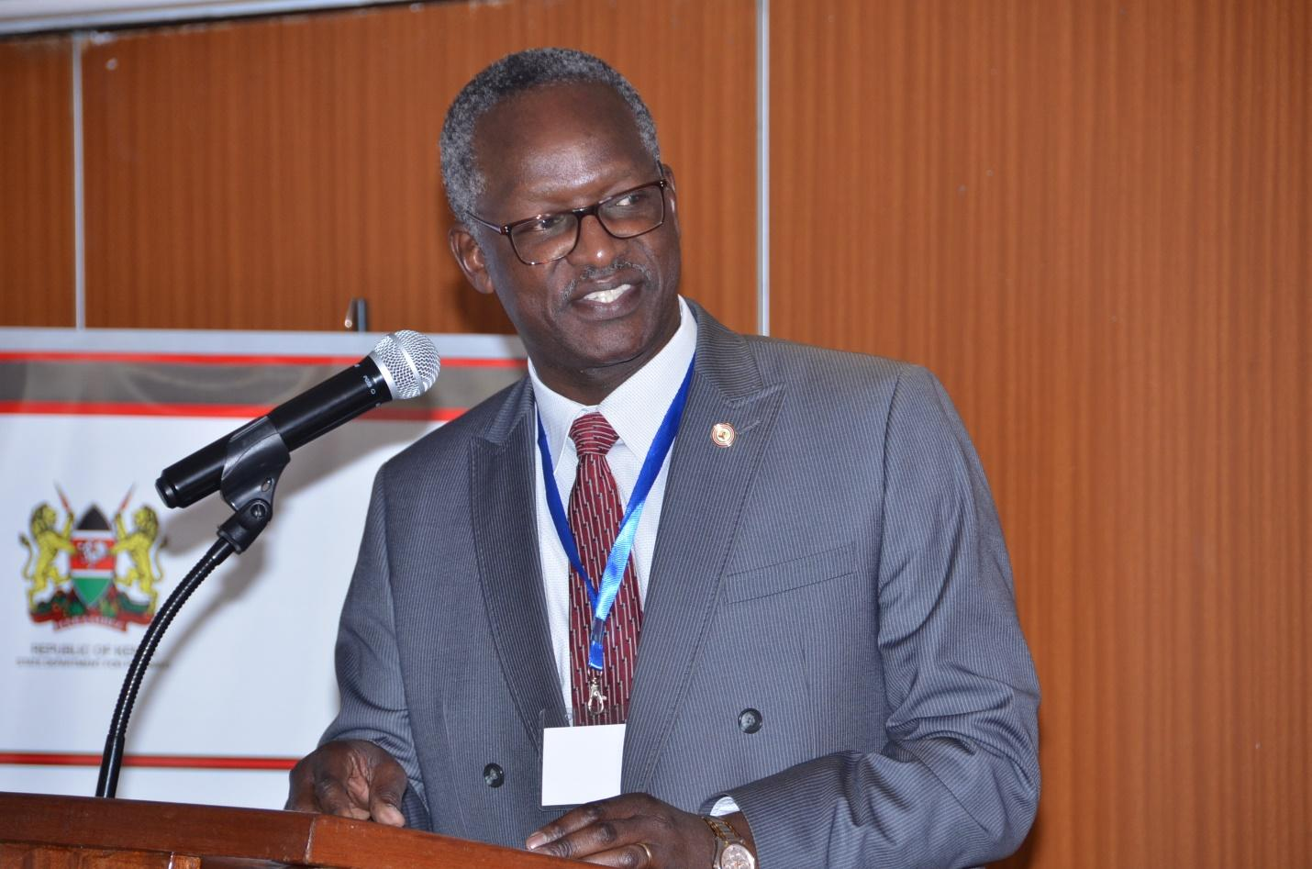
Photo 2: Ambassador Ogutu Moderating the Session
The mini- conference was brought to life through an introductory remarks by Ambassador Ogutu, from the Ministry of Foreign Affairs. He highlighted the outcome of the TICAD VI Conference that was held in Nairobi in August 2016 in Nairobi, Kenya that was the first to be held outside Japan. The conference called for Africa ownership of projects and ideas but with international partnerships. That the conference brought together not only heads of states but also the private sector, Civil Society Organizations (CSOs) and the development partners. It brought to the forefront the benefits and necessity for Public-Private Partnerships.
Amb. Ogutu further reiterated the three objectives of the mini conference and especially the need to monitor the implementation of the Nairobi Declaration and further discoursed the three pillars of TICAD VI that were:
- Promoting structural economic transformation through economic diversification and industrialization
- Promoting resilient health systems for quality life
- Promoting social stability for shared prosperity
He pre-empted the need and direction of TICAD VII which will be held in Japan in 2019. He also echoed the fact that TICAD is a process where each part builds on the previous one and thus TICAD VII will build on TICAD I through to VI.
He urged the participants to get involved in the forthcoming Global Sustainable Blue Economy Conference that will be held in November 2018 in Nairobi Kenya. This is the first of its kind to ever be convened. Both the Blue Economy Conference and TICAD ties in with Kenya’s Big 4 Agenda of Manufacturing, Universal Healthcare, Affordable Housing and Food Security.
The Next Speaker was Mr. James Maina from the State Department of Planning who gave a summary and status report of TICAD VI implantation in Kenya under the three pillars.
In his presentation, Mr Maina mentioned that the TICAD VI Declaration highlighted challenges and international development priorities requiring attention, and building on the TICAD guiding principles, including the imperatives of human security and engagement of multi-stakeholders, and affirmed that the following pillars were identified under TICAD VI. He highlighted the three TICAD pillars to include:
Photo 3: Mr Maina making his presentation
Pillar 1: Promoting Structural Economic Transformation through Economic Diversification and Industrialization (Economic diversification and industrialization, Quality infrastructure, Private sector development, Human resource development, Public-private partnership)
Pillar 2: Promoting Resilient Health Systems for Quality of Life (Health system strengthening, Response to public health crises, Universal health coverage, Nutrition)
Pillar 3: Promoting Social Stability for Shared Prosperity (Social stability and peacebuilding, Terrorism and violent extremism, Global issues and challenges, Maritime security, United Nations in the 21st century)
He went further to elaborate the strategies for TICAD’s cross-cutting areas such as: Empowering youth, women and persons with disabilities; promoting science, technology and innovation; Human resource development; human resources development; and advancing Public-Private-Partnerships.
Lastly, Mr Maina informed participants that TICAD allows a follow-up mechanism in the following forms:
- Joint Secretariat for robust monitoring and reporting
- Joint Monitoring Committee
- Follow-up meeting
- Senior officials meeting
- Ministers’ meeting

Statements from Representatives of TICAD Co-organizers

UNDP
UNDP was represented by MR. SIDDARTH CHATTERJEE, the United Nations (UN) Resident Coordinator and United Nations Development Programme (UNDP) Resident Representative.
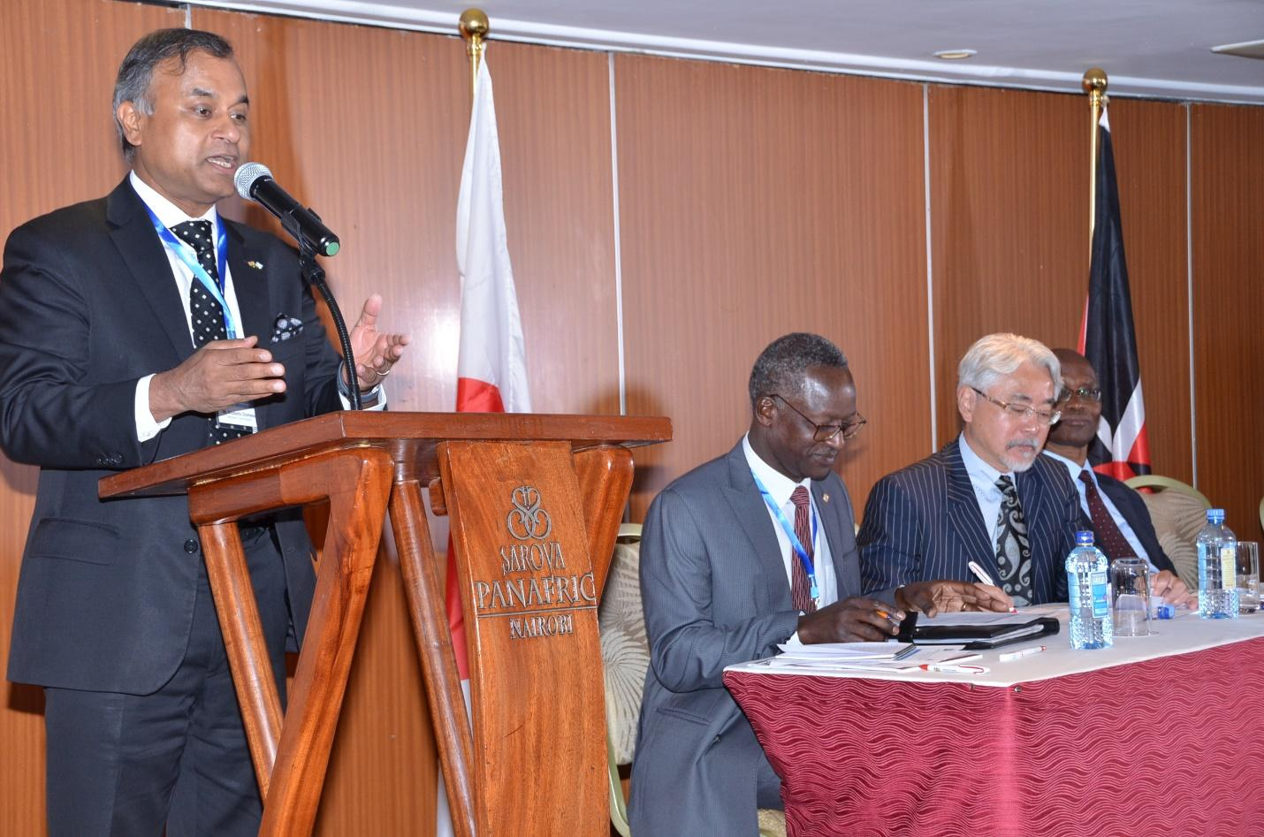
Photo 4:Mr. Siddarth Chatterjee makes his opening statement

In his opening remarks, Mr. Mr. Siddarth Chatterjee expressed his pleasure to represent UNDP at the TICAD Mini Consultative Conference.
The United Nations (UN) Resident Coordinator and United Nations Development Programme (UNDP) Resident Representative began his address by congratulating UNDP for being the longest serving partner of the Japanese government in the TICAD process. Co-organizing TICAD process provides UNDP with important strategic advantages, including: (1) facilitating global discourse on Africa’s development; (2) promoting innovative partnerships; (3) raising UNDP’s visibility as the leader/coordinator of the UN Development System; and enhancing strategic partnerships with japan in Africa as the key driver of the corporate strategic partnership with Japan.
TICAD VI, the epoch-making first TICAD summit in Africa, was held in Nairobi, Kenya in august 2016 with 11,000 participants. In addition to African heads of states, Japanese Prime Minister and Foreign Minister, heads of co-organizers and international organizations, the strong participation of Japanese and African private sector was the key feature of TICAD VI. TICAD VI adopted the Nairobi declaration: (1) Promoting structural economic transformation through economic diversification and industrialization, (2) Promoting resilient health systems for quality of life, and (3) Promoting social stability for shared prosperity, as priority areas. As a follow-up to TICAD VI, the TICAD Ministerial meeting was held in Maputo, Mozambique on 24-25 august 2017. African ministers discussed the “overview of progress since TICAD VI”, the “economic transformation of Africa’s Growth”, and “promoting human security and resilient societies”.
“Strategic partnership with Japan has also been significantly enhanced. Since TICAD IV (2008), UNDP in Africa received more than 620 million USD from Japan. Crisis prevention/recovery and democratic governance are the two major areas of funding, followed by environment. UNDP is also the largest recipient of the UN Trust Fund for Human Security, which has been almost entirely funded by japan. Further, UNDP is scaling up collaboration with JICA at HQ and country levels. In 2016, JICA and UNDP agreed to extend the annual consultations to the country levels. Based on initial feedback, 11 countries (Cameroon, DRC, Ethiopia, Ghana, Malawi, Mozambique, Rwanda, Senegal, South Africa, Tanzania and Zambia) have been selected as “priority” (1st batch) countries, and further consultations are underway.” He continued to say.
He praised TICAD for being transformative and gave a few brief points about what the UN would like to see going forward. He underscored the importance of the upcoming Blue Economy Conference in helping to address unemployment brought about by Kenya’s youth bulge. With Kenya being a gateway to the rest of East Africa, then Japan’s investment in the Port of Mombasa is crucial in the development of the economy. He also gave some figures showing the massive opportunities expected to be brought about by growth of Africa’s economy: growth in the healthcare business to about USD 300 billion by 2030, growth in the agricultural sector to USD 1 trillion by 2030 and growth in Africa’s consumer market to USD 2.5 trillion by 2030.
He touted TICAD as the gateway to a Martial Plan in Africa and how its transformative agenda focuses on all sectors by helping in identification of key investment areas. He shared his view concerning the four E’s of Education, Empowerment, Employment and Equity and how vital they are to development and gave an example of how KES 94 Billion is lost annually due to gender inequality.
He stressed that the report on Gender Empowerment launched by TICAD VI would assist in combating this problem and urged Kenya to learn from Japan on how to achieve its Big 4 Agenda especially on the sector of Blue Economy.
Last but not least, Mr Siddharth reiterated that the presence of a wide range of stakeholders in TICAD is a reaffirmation of the strong partnership TICAD enjoys with various partner institutions. Considering this, TICAD VII Preparatory process will intensify in 2018. UNDP is expected to mobilize its substantive, technical and operational capacities, as well as bureau and corporate leadership, to support the process and ensure the success of TICAD VII.
Lastly, Mr Siddharth mentioned that for UNDP to consolidate its positioning in the global discourse on Africa’s development as well as the strategic partnership with Japan in Africa, it needs to continue to (1) engage with Japan and other stakeholders and ensure representations in the TICAD process at the highest levels, (2) leverage its substantive, technical and operational strengths to further enhance TICAD, and (3) further improve on timely delivery and reporting of Japanese funded projects in Africa.

World Bank
The World Bank was represented by Mr. JOHANNES ZUTT, the World Bank Kenya Country Director.
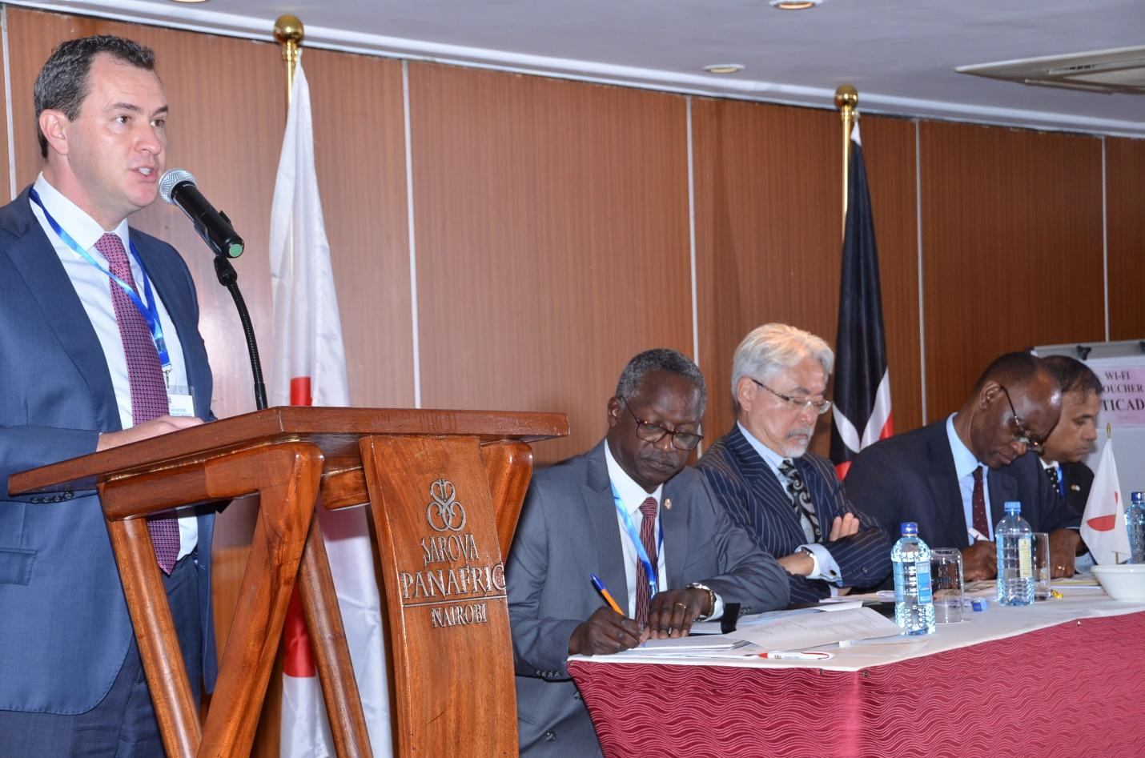
Photo 5: Mr Johannes Zutt making his opening statement

Mr Johannes Zutt, opened his statement by affirming the World Bank’s commitment to the TICAD process. He was pleased to note that the Big 4 Agenda is closely aligned with the three TICAD pillars and that they provide an additional framework to implement the TICAD strategy. He stated that the World Bank was looking forward to the launch of the Third Medium Term Plan of Vision 2030 (MTP III) which would provide a framework to operationalize the TICAD process. The World Bank had so far had a successful partnership in promoting Universal Health Care, and the project was expected to roll out in 4 counties in 2018.

African Union
The African Union was represented by DR. MOHAMED SEISAY, the African Union Inter-African Bureau for Animal Resources (AU-IBAR).
Dr. Mohamed Seisay made a statement on behalf of the Director of the African Union Inter-African Bureau for Animal Resources (AU-IBAR). In his presentation, he conveyed sincere appreciation of Her Excellency Mrs. Josefa Leonel Correia Sacko, the Commissioner of Rural Economy and Agriculture of the African Union Commission and His Excellency Dr. Mousa Faki Mahamat, chair of the African Union Commission to the organizers for the invitation extended to the Africa Union.

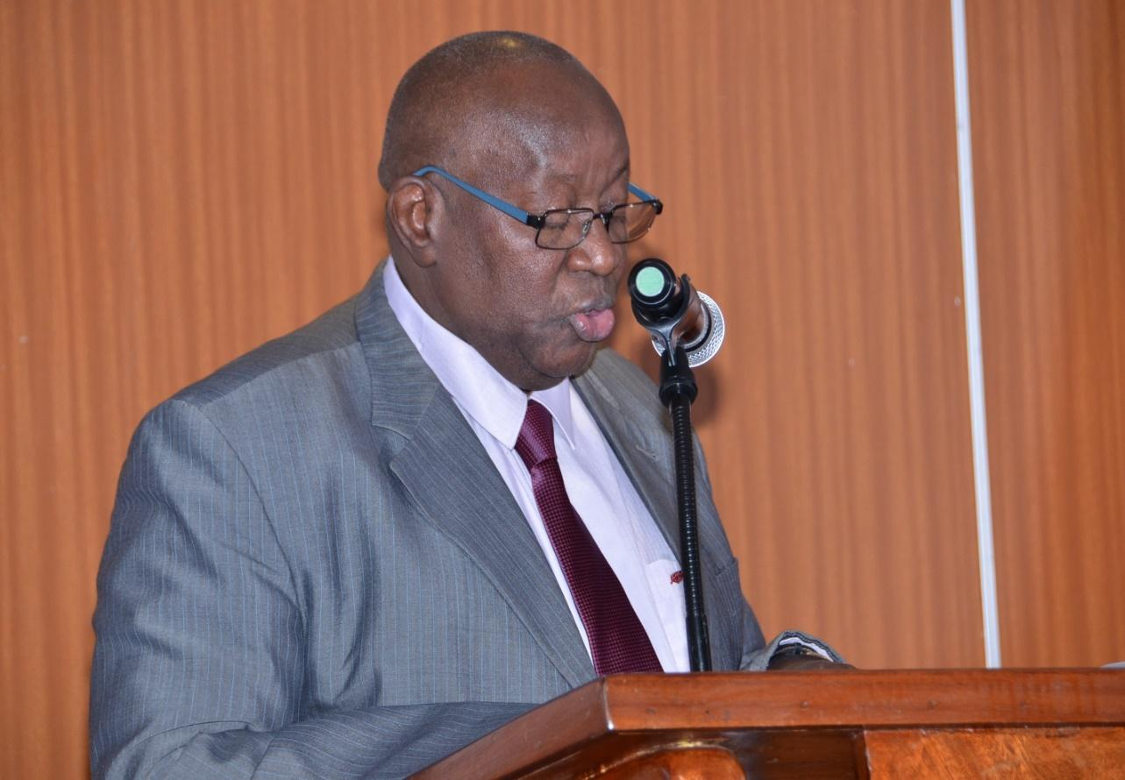
Photo 6: Dr. Mohamed Seisay Making his Statement
The African Union Inter-African Bureau for Animal Resources (AU-IBAR) is a specialized technical office of the Department of Rural Economy and Agriculture (DREA) of the African Union Commission. Over the years the mandate of AU-IBAR has become broader, which is to support and coordinate the improved utilization of animals (livestock, fisheries, aquaculture and wildlife) as a resource for human wellbeing in the Member States of the African Union (AU) and to contribute to their economic development assets for the mostly impoverished rural African population, and for marketing and trade.
From the perspectives of Fisheries and Aquaculture contribution to Blue Economy growth he mentioned that African Union has taken bold steps in an endeavour to harness the full potential of its aquatic and marine resources living resources for enhanced contribution to blue economic growth development. Due to the seemingly intractable challenges to maximizing the benefits of these resources, as part of the strategy for contributing to blue economy growth initiative, the Policy Framework and Reform Strategy for Fisheries and Aquaculture was developed and endorsed by 23rd Summit of African heads of States and Governments in Malabo, Equatorial Guinea, June 2014.
During the 6th TICAD Conference in Nairobi in 2016, AU-IBAR had the privilege to collaborate with the then Kenya State Department of Fisheries and Blue economy and development partners to organize a side event on blue economy. AU-IBAR sincerely appreciates the Kenyan Government for this opportunity.
Lastly, he reiterated that the African Union fully embraces the concept of Blue Economy Growth underscored by a responsible and sustainable approach that is more environmentally, socially and economically effective. Thus Blue Economy development approach is fully embedded in the African Agenda 2063 which is a strategic framework document for inclusive growth and sustainable development. In this respect, one of the main goals of the AU Agenda 2063 is the development of Blue/Ocean Economy for accelerated economic growth. Key priority areas to achieve this goal among others, are the sustainable management of fisheries and coastal resources, maritime transportation and mining.
Dr. Seisay’s sentiments were supported by Ambassador Ogutu who recognized the role the AU has played in supporting Kenya to adopt Africa’s Agenda 2063.

The Government of Japan
The Government of Japan was represented by H.E AMB. UESAWA, the Japan Ambassador to Kenya.
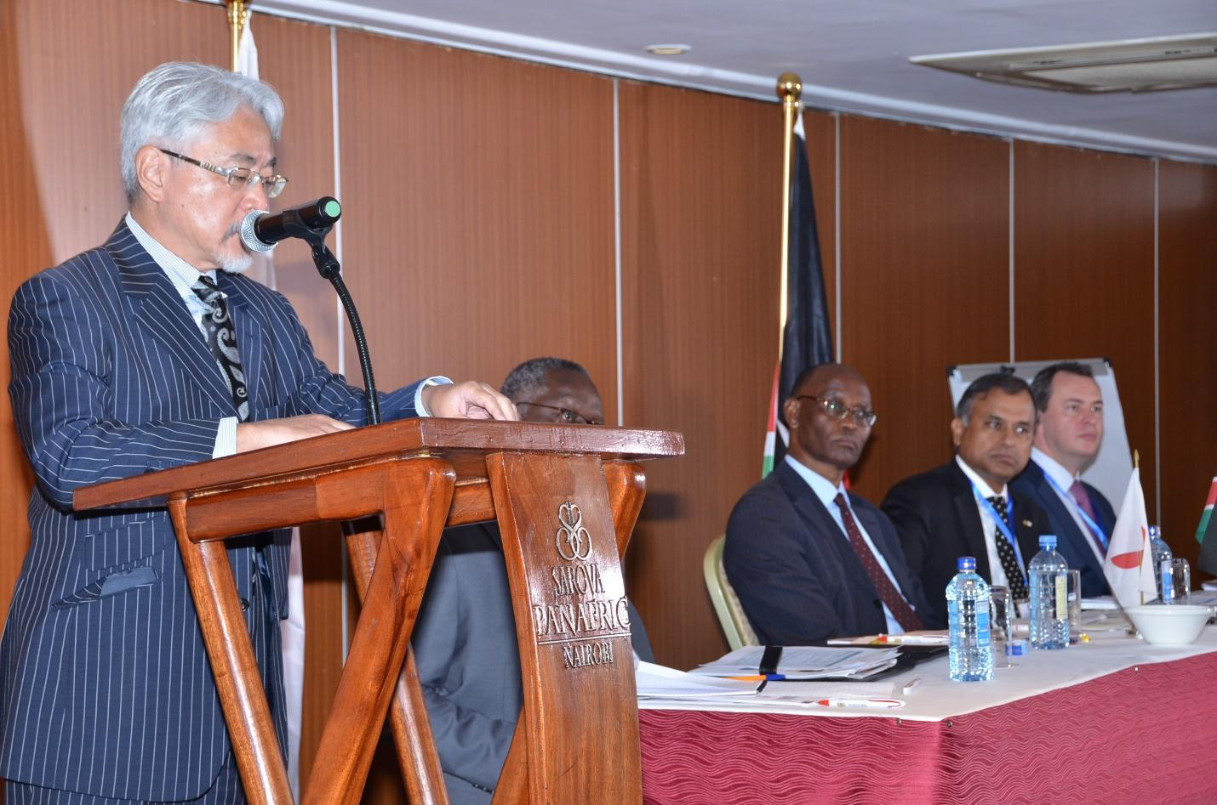
Photo 7: H.E Amb. Uesawa making his remarks
H.E the Ambassador, expressed his gratitude for having the conference as an initiative of the people of Kenya. It serves as a reminder of one of the core concepts of TICAD-African ownership, and international partnership.
In 2016, TICAD VI was held in Nairobi, this being the first time that this conference was held on the African continent. Arising from this TICAD VI was the Nairobi Declaration, which came up with a number of pillars on which development cooperation between Africa and Japan would be anchored. Reports indicate that tangible progress has been made in a number of areas, since the Nairobi Declaration.
He went on to state that the TICAD pillar of “Promoting structural economic transformation through economic diversification”, has yielded the Mombasa port development project; the Mombasa Special Economic Zone Development Project; the Dongo Kundu Bypass; the Olkaria geothermal plant; and the Ngong Road expansion project among others.
The area of “Human resource development” has also had the ABE Initiative which is a programme that sends young Kenyans with leadership potential to study for advanced degrees in japan. In the process, they also get exposure to the Japanese methods in manufacturing and innovation.
The pillar of “Promoting resilient health systems for quality of life”, has the Health Sector Policy Loan for Attainment of the Universal Health Coverage. This is in addition to human resource development through various technical assistance programmes.
In the pillar of “Promoting social stability for shared prosperity”, we have an example in the Mwea Irrigation Development project, as well as the technical assistances to increase the farmer incomes and to ensure food security.
He informed the participants of the Japanese international cooperation’s role that is promoted under the big picture of TICAD which reflects the very same priorities as those of President Uhuru Kenyatta’s Big Four agenda. With this, Kenya is expected to continue to lead other African nations in development cooperation with Japan.
In this spirit, he reiterated the Government of Japan’s continued commitment to the TICAD process and in the preparations for TICAD VII.

Government of Kenya
The Government of Kenya was represented by MR. JOSEPH MIUKUI who is the Economic Planning Secretary, in the State Department for Planning who also gave the Key Note address on behalf of Dr. Julius Muia, EBS, and Principal Secretary in the State Department for Planning
In a statement read on his behalf by Mr. Joseph Mukui, Dr. Julius Muia, EBS, Principal Secretary, State Department for Planning, Dr Muia expressed his delight in celebrating the growth of the Japan-Africa Cooperation through TICAD which remains core in the promotion of high-level policy dialogue between African leaders and Development Partners, as well as mobilization of support for African-owned development initiatives.

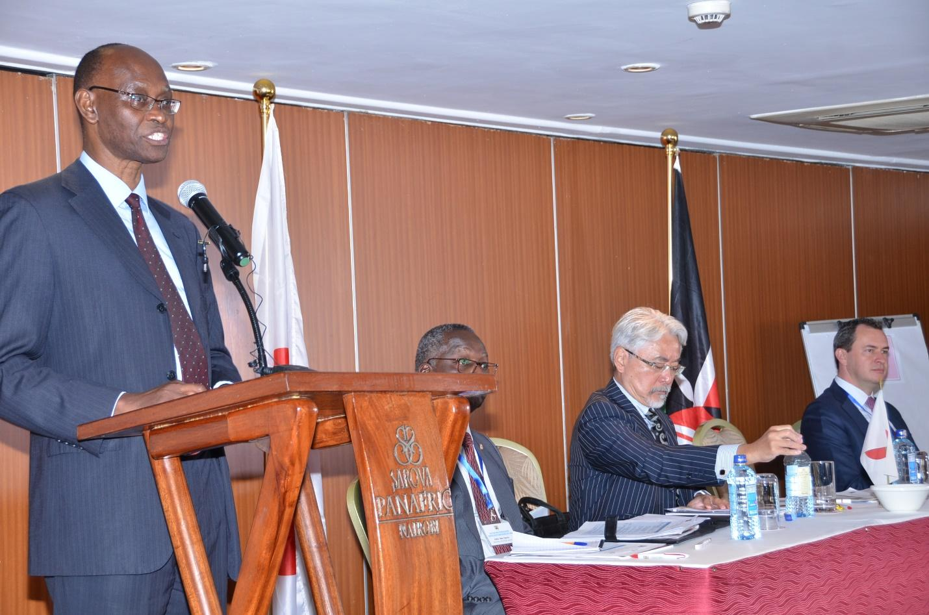
Photo 8:Mr. Joseph Mukui Giving Key Opening Remarks
He saluted efforts put together towards ensuring the success of the mini-conference. It will go a long way in promoting visibility of TICAD programmes in Kenya. He mentioned that from the outset, the TICAD framework has continued to grow to attract major global partnerships around Africa’s development under the principles of African “ownership” and international “partnership”. This was witnessed during the Nairobi, TICAD VI Summit, through the various programmes that attracted attention and participation from across all regions and a wide range of organizations around the world. Further, besides the official TICAD VI programme, the Forum witnessed 74 side event and a total of 73 MoUs were signed.
For Kenya, TICAD remains a resounding cornerstone of national development and a strong beacon for promoting international partnership. To-date, the Country has received a cumulative assistance from Japan totalling about ¥ 609.077 billion or (approx. ksh.622.503 billion) in form of technical assistance, grants and loans. This support has gone into implementation of the following programmes/projects: Jomo Kenyatta University of Agriculture and Technology (JKUAT); Kenya Medical Research Institute (KEMRI); Mombasa Airport Improvement Project; New Nyali Bridge; Mtwapa Bridge and Kilifi Bridge; Rehabilitation of Athi and Ikutha Bridges; Kapsabet Water Supply; Sondu Miriu Hydropower Project; Improvement of Facilities in Kericho and Kisii District Hospitals and Construction of the Nairobi Missing Links; and Support Universal Healthcare Coverage.
Other programmes that have benefited from Kenya’s partnership with the Government of Japan include: implementation of the Nairobi Missing links Project; Duelling of Nairobi-Dagoretti Corner Road; Baringo Water Supply; Narok Water Supply; Grant Aid for Japanese SME Products; and Medical waste and Hazardous Waste Appropriate Processing Plant. The country has also witnessed, an accelerated implementation of programmes which either continued from TICAD V and completed during the TICAD VI or initiated during TICAD VI period and are continuing. In this regard, these are some of the recently executed projects:
In the energy sector, the country received commendable support towards the 140MW Olkaria 1 Unit 4 & 5 Geothermal Power Project and the renewable energy model for rural electrification supporting installation of solar Photovoltaics (solar PV) with commercial activities in rural schools and dispensaries which have been completed. In addition, the drilling of Olkaria V Geothermal Power Development project; the Olkaria 1 Unit 6, 70MW Geothermal Power Project; and the 300 km 400/220kv Olkaria-Lessos-Kisumu Transmission line are some of the ongoing projects.
During the same period the construction of Dongo Kundu Bypass-Pachake 1 Miriti-Mwache Road under the Mombasa Port Development; Nairobi western missing link road; rehabilitation/expansion of Kenya National Library-prestige junction; and rehabilitation/ expansion of Prestige Junction-Dagoreti Corner among other key infrastructure projects were concluded.
The country also received Japanese support to strengthen resilience against frequent drought through smallholder community-based irrigation projects in eight counties; study on rice-based food value chain in Mwea and Lake Victoria Basin; and capacity development project for enhancement of rice production in irrigation schemes targeting Mwea, Ahero and West Kano Irrigation Schemes.
The Kenya/Japan partnership has also resulted in major boosts to National Human Resource Development through the following: the project for Expansion of the Centre for Mathematics, Science and Technology in Africa (CEMASTEA) which aims at promoting quality teaching and learning of Science and Mathematics; productivity improvement focusing on technical transfer of productivity improvement and the ongoing Africa Kaizen Initiative (AKI) which is a joint initiative by NEPAD and JICA to promote and disseminate Kaizen throughout Africa.
At the National level, he continued to say, Kenya is in the final stage of preparing the 3rd Medium Term Plan of the Kenya Vision 2030, which details the nations development priorities for the next five years, and which constitute the basis for continued collaboration and partnership. On the same note, these priorities also include the “Big Four” Government Initiatives that aim at: guaranteeing food security and improved nutrition to all Kenyans by 2022; providing at least five hundred thousand (500,000) affordable new houses to Kenyans by 2022 to improve living conditions for Kenyans; supporting value addition and raising the manufacturing sector’s share of GDP to 15 per cent by 2022 to accelerate economic growth, create jobs and reduce poverty; and providing Universal Health Coverage thereby guaranteeing quality and affordable health care to all Kenyans.
In conclusion, he emphasized HE President Uhuru Kenyatta’s key note address during plenary of TICAD VI, which underscored TICAD’s shared vision for Africa’s development and the need for: free trade as a prerequisite for shared prosperity for all; partnerships to support African enterprise and development aspirations; global commitment and efforts to defeat terrorism which is an impediment to development and social stability. These were further reinforced by H>E. Prime Minister Shinzo Abe who stressed that quality, resilience and stability were hallmarks of prosperity.
Finally, he reiterated Kenya’s expectation in enhancing collaboration as we approach TICAD VII and in all the continuing programmes while remaining positive on identification of new partnership areas like harnessing potentials inherent in the Blue Economy, among other new proposals for future partnership.
With this, the Principal Secretary declared the conference officially open and wished participants a fruitful deliberation.

STATUS OF TICAD IMPLEMENTATION
______________________________________________________________________________
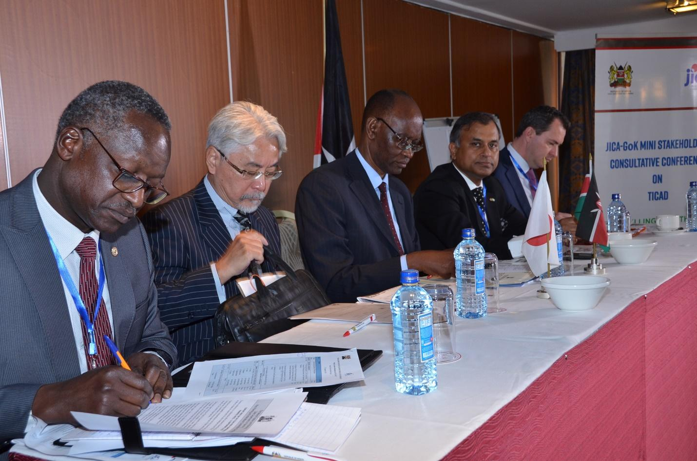
Photo 9: Chief Guests Listen to the Proceedings during the Conference

Sub-Theme 1: TICAD and Economic Growth
The first presentation session featured speakers from the Trade, Water, Infrastructure, Industrialization, Crops and Industrialization subthemes.

Trade
The session on trade was presented by Mr. Bramah Kaleve from the Directorate of International Trade, State Department of Trade, Ministry of Industrialization, Trade and Cooperatives. The presentation focused on JICA’s assistance on human resources (HR) development.
He stated that the ministry initially wrote to JICA in 2015 requesting HR development assistance. The JICA project in the Ministry of Trade had the objective “To realize growth in Small and Medium Enterprise (SME) performance through HR development” while the aim was to promote business training. The Kenya Institute for Highways and Building Technology (KIBIT) was the implementing institution on the programme. Among the output of the programme included improvement in the KIBIT implementation mechanism by trainers lecturers on how to work with SME’s, training of trainers on business plan development, revised guidelines and tools, the appointment of 10 ministerial committees. The programme was completed in 2017 and a one-year extension granted in 2018.

Water Sector
The Water subtheme presentation was made by Engineer Isaac Kimani from the Ministry of Water and Sanitation. He began by saying that the Ministry has implemented 3 projects with JICA’s support. Two of the projects were aimed at directly increasing access to water, while one was a capacity-building project to reduce Non-Revenue Water (NRW). The objective of the Narok Water Supply Project was to improve Water Supply in Narok Town.
Through the project, the Ministry increased water supply in Narok by 5000 m3/day, serving 50,000 people. The scope of the project included transmission lines and water storage facilities. The project also had a capacity building component for the Water Service Provider (WSP) in the area.
The second project tackled Rural Water Supply in Baringo with the aim to increase water supply in the rural areas of Baringo County. 70 productive boreholes were drilled in the target villages and water extraction facilities were also built, catering for both people and livestock. Capacity building to communities was also done. The output of the project was 30,000 m3/day of water serving 80,000 people and their livestock.
The third project under the Ministry was a technical co-operation aiming to strengthen capacity of stakeholders in the water sector NRW reduction. The aim of the project is to reduce NRW to less than 30% of current losses by 2022. This will result in a savings of Ksh. 10 billion annually, which can be used for equipment maintenance and increasing access to water in the country. Phase 1 of the project was a preparatory phase which was completed in 2017. Phase 2 commenced in June 2016 and involves data analysis, sensitization of WSP’s, training at the Kenya Water Institute (KEWI), Capacity building for WSPs and finalization of monitoring tools to be used by the Water Services Regulatory Board (WASREB).
    - Infrastructure
Mr. Boniface Maikya made the presentation on behalf of the State Department of Infrastructure, Ministry of Transport, Housing and Infrastructure. He mentioned that JICA support to the Ministry has encompassed roads projects as well as a capacity building component. A summary of funded roads projects is presented below:
- Dongo Kundu Bypass to decongest Mombasa port: Phase 1 I complete and open, Phase 2 is currently under procurement while the contract for phase 3 has been signed and is awaiting the next steps
- A feasibility study for the Mombasa Gate Bridge to connect Mombasa mainland to the south coast at Likoni is currently ongoing
- The Nairobi missing link project aiming to widen roads and introduce safe road design for non-motorized transport users was completed in 2014. Phase one of the widening of Ngong Road up to Prestige Mall is complete while Phase 2 from Prestige to Dagoretti Corner is ongoing.
- Feasibility studies for the construction of the Nairobi Viaduct and widening of Enterprise Road are ongoing
Capacity building was conducted for Kenyan roads authorities including Kenya Rural Roads Authority (KERRA), Kenya Urban Roads Authority (KURA) and Kenya National Highways Authority (KENHA). Phase 2 of this was completed in 2016 and involved production of manuals on performance-based contracting on roads maintenance. These included manuals on cost estimation for contractors, engineers and the Kenya Roads Board. Training for contractors was also done in conjunction with the Kenya Institute of Highways and Building Technology (KIBIT).
    - Industrialization
The Industrialization component was represented by Mr. Samuel Mwangi, State Department of Industrialization. JICA has supported two projects within the State department of industrialization: These projects include the establishment of a Special Economic Zone (SEZ) in Mombasa and One Village, One Product Project (OVOP). The Masterplan for the Special Economic Zone has also been completed and is awaiting implementation. So far, the SEZ Authority has been established.
The OVOP project has focused on supporting SMEs in 7 counties in the country. The OVOP project involved providing technical training to SMEs in industries such as honey, dairy and soap-making. This has led to increase in profits to the SMEs. Mr. Mwangi gave an example of support to basket weavers in Taita Taveta County to brand their products appropriately, which led them securing an export market in Japan and other countries for Taita Baskets. Support to Kisii soapstone carvers in proper finishing for their products also led to them being able to secure an export market. The other component of the project was to provide support to other Kenyan counties and African countries to develop the OVOP model. Training was carried out with 8 African countries and 5 counties in Kenya.
    - Crops
The presentation was given by Mr. Steven Kioko representing Francesca Malenge of the Smallholder Horticulture Empowerment and Promotion Project for Local Upscaling (SHEP PLUS). The SHEP PLUS project has been working with farmers to promote a “Grow to sell” rather than ‘Grow then sell’ approach that is, having a market first before growing crops for sale. Currently, the SHEP approach is being expanded to other African Countries with trainings offered to both Anglophone and Francophone countries. So far, the project has reached 23 African countries and 500 agricultural officers. Among the lessons learnt from implementing the programme include the importance of market survey as a key to success, the importance of having focused stakeholder forums, and the important role played by training in gender mainstreaming and joint decision making around family resources to ensure gender equality.
    - Irrigation
Mr. Phanwel Webi from the State Department of Irrigation, Ministry of Water and Sanitation made the presentation. Mr. Webi began his presentation by briefly describing the history of Japan-Kenya co-operation in irrigation.
The collaboration began in 1998 with a study on irrigation development in the Mt. Kenya region. From 1998 to 2003, the Japanese government provided technical support to develop manual on irrigation training. Between 2005 and 2010, Japan supported the development of 6 projects for smallholder irrigation development and management: two in Narok County, two in Embu County (Kerokungu and Kiambindu), and one each in Kajiado County and Makueni County.
From 2009 to present, JICA has supported various irrigation projects across the country including expansion of the Mwea project by 4000 ha and construction of Thiba dam. After TICAD VI, the Japanese institute for Irrigation did a study on the food value chain in Mwea and the Lake Basin. Follow up is being done to design the project and to look at expansion of Ahero, West Kano South West Kano regions. Intake works are currently ongoing at Nyatik in the lower Kuja Irrigation Project. Technical cooperation will also be provided after the study. The target commodity in Japanese markets is irrigated rice and thus Kenya has developed a Rice Development Strategy 2013-2016 which aims to take Kenya from the current 30% self-sufficiency in rice production to 100% by 2030.

Plenary Session 1
The plenary session allowed participants to engage with presenters on a number of issues regarding Japanese cooperation in Kenya.
- There was a question of whether Kenya has ever conducted an agricultural census to identify priority counties and farmers for training to allow for good planning in project identification and implementation.
Currently there is clear criteria for identifying groups of stakeholders through which project implementers such as SHEP carry out their activities. SHEP uses the criteria to select five farmer’s groups in each county, two of which must be composed of members from special groups (Women, Youth and the Disabled).
The 2019 census is also close to being conducted and will provide further data that the government will use in designing its projects.
- Participants also brought out the importance of sustainability of projects after completion and the need to discuss challenges facing the projects and how these can be overcome.
SHEP’s training for farmers also encourages self-sufficiency by encouraging them to do their own crop selection and marketing. Human Resource Development Training for SME’s has included training in book-keeping and other priority areas to encourage small business owners to become more effective at running their own businesses.
- Capacity Development to KIBIT under the Transport Ministry gives them the resources and knowledge to continue with the human resource development after the end of the project. An impact survey of the OVOP project under the Ministry of Industrialization showed that SME’s were able to get market for their products after being trained in using the model. In infrastructure, the projects have a ‘Divest Liability’ period factored in to allow the contractor to continue maintaining the road for a period before handing over to the relevant authorities. The need for monitoring and evaluation as key to inform further action beyond the presentations of the projects. Evaluations during the mid-term and end-term of projects are factored in during the next phase.
- There was also a question on what challenges have been encountered in irrigation project development in the Western regions where the State Department of Irrigation is cooperating with the Japanese government to develop.
It was stated that the Ahero and West Kano projects are not seen to be growing in terms of productivity. An example was also given of American Company Dominion which faced challenges in developing the region. The biggest challenge in irrigation was stated to be need for a comprehensive regulatory framework to be developed.
The Irrigation Act of 1966 Cap 367 established the National Irrigation Board (NIB) and later led to the establishment of the Ahero, Bunyala and West Kano irrigation projects. JICA has supported the development of the Irrigation Policy and Act since 2003. A draft version was completed by 2009 with support of the World Bank. The Irrigation Policy was approved in 2017 and the Irrigation Bill was approved by the National Assembly and is currently in the Senate. Issues such as land tenure and wayleaves are still being worked out as well as National and County government roles in management of the irrigation projects under development.
The Dominion project in Yala identified 4000 hectares for irrigation development which were leased to Dominion by the Lake Basin Development Authority. However, lack of a clear framework on how the local community would benefit delayed implementation and the company pulled out of the area. The Ministry of Irrigation is currently working with the county government to address these challenges to allow the project to proceed. In the Lower KUJA project, Capacity Development support is being given to farmers including processing and marketing of rice in order to maximise benefit to the local community. Ahero and West Kano are also expected to be linked through gravity irrigation system. The State Department of Irrigation is currently tackling challenges of capacity development, efficiency and flows of water to make the project work.
- An issue was also brought out about the lack of interconnectedness of the projects being implemented by the government with support of the Japanese government.
However, presenters emphasized that there is already interconnectedness between the projects the different ministries are carrying out. For example, the multi-purpose dams being implemented by the Ministry of Water and Sanitation will also supply water for irrigation in those areas.
- There was a question on whether a study on underground and surface water has been carried out in order to inform utilization. This has been provided in the National Water Master Plan 2030 which classifies water resources by region and approximate volume. Groundwater mapping is also underway. Furthermore, the Plan has a sectoral report on irrigation potential in each region based on available resources. The Nile Basin Initiative plans have also been captured since the planned projects in the Western Region fall under the Nile Basin. Integrated Water Resource Management principles have also been applied in project implementation.
On implementation, participants stated the need to see the number of beneficiaries increasing and need to include other stakeholders in the process in order to put citizens at the forefront of development projects.
- There was question on what constitute administrative losses of water and what the outcomes of the Non-Revenue Water Project have been.
The Water and Sanitation Official was also asked to elaborate of whether an integrated water management approach has been used to inform the Ministry’s projects. Administrative losses are those attributed to administrative processes such as billing errors or uncollected revenue. The outcomes of the NRW water project are yet to be documented since the project will continue until 2022. However, monitoring and evaluation is expected to continue to be part of all ongoing TICAD projects.

Sub-Theme 2: TICAD and Agricultural Development

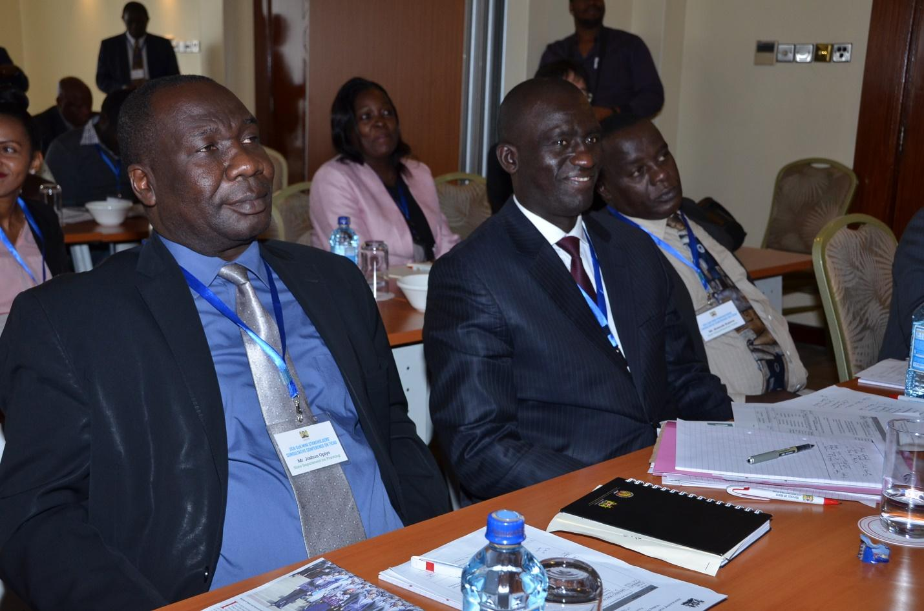
Photo 10: Participants Keenly Follow Proceedings during the Conference

Health
Dr. Peace Masinde, Coordinator of International Health Affairs, Ministry of Health gave the presentation on health.
Dr. Masinde began her presentation by emphasizing the Ministry of Health’s immediate and pressing priority which is the provision of Universal Health Care by 2022 under President Uhuru Kenyatta’s Big 4 Agenda. The delivery of Universal Healthcare has four strategic objectives: 1) Expansion of the Benefits Package 2) Essential Health Interventions 3) Protection from Financial Catastrophe 4) Ensuring Adequacy of Health Resources. Dr. Masinde then gave an update on project developments in the Ministry since TICAD VI. Under Pillar 2, the Ministry has implemented six projects under three thematic areas namely Health Systems Strengthening, Response to Public Health Crises and Universal Health Care Access. These projects include:
- The Kenya Universal Health Sector Support for Universal Healthcare. The project ran from 2015 to 2017 and focused on the following areas: Free Maternity Services, Results-Based Financing, Health Insurance Subsidy Programme, and Universal Healthcare Study Tour.
- The Japanese government also provided technical support by seconding a Universal Healthcare Advisor who is an expert in Healthcare Economics and Finance to the Ministry of Heath from 2017 to 2019.
- Technical support has also been given through the Organizational Capacity Development for Management of Devolved Healthcare Systems (OCCADEP) programme which began in 2014 and will run until 2019. The programme is expected to strengthen coordination structures, carry out a skills gap assessment and provision of machines and office equipment to the counties.
- The partnership for Health Systems Strengthening in Africa Programme
- The Policy and Human Development Trust Fund is also being implemented to support Universal Healthcare and pandemic preparedness and support.
- The Government of Japan Grant for economic and social development programme has donated 400 million Yen for Cancer equipment and Capacity Development support for staff in cancer detection in the county.
    - Basic Education
This component was presented by Dr. Loise Macharia from the Ministry of Education who presented on the projects currently being implemented by the Ministry of Education with support of the Japanese government.
The G-United Volunteer programme sends graduates to the counties, particularly disadvantaged areas such as the ASALs and poverty pockets such as urban informal settlements. The aims of the project are to promote national cohesion, to strengthen primary education outcomes for struggling learners and to enrich personal development skills for youth through community service. The graduate volunteers are trained in how to handle struggling learners to assist them in the classroom setting.
Through the Third Countries Training Programme (TCTP), the Ministry of Education has been working to introduce the Centre for Mathematics, Science and Technology Education Africa (CEMASTEA) to Anglophone African Countries and to train Science, Technology, Engineering and Maths (STEM) teachers from Francophone countries to apply gender responsive teaching practices.

Plenary Session 2
- While under the leadership of Dr. Mukhisa Kituyi, the former Minister, the Ministry of Trade has a vision to position Kenya as a hub for trade in services with health being a major pillar of this strategy through provision of medical services in 4 areas: Epidemic management, catastrophic health services, referral and training of medical personnel.
The participants asked whether this was still being considered by the Ministry of Health. There have been several attempts to develop a medical tourism strategy, and Nairobi is already a hub for medical treatment but the government cannot do it alone. The strategy is currently in draft form and support is needed from government’s partners to complete the process, even as the Ministry of Health focuses on the immediate priority of delivering the Universal HealthCare pillar of the Big 4 Agenda.
Some challenges that need to be overcome include ensuring the quality of medical tourism. The passing of the Health Bill 2015 is a step towards overcoming these challenges.
The Public-Private-Partnerships unit at the National Treasury has a Health sector which can hopefully come up with a framework on which to anchor the medical tourism strategy. On the issue of marketing Kenyan healthcare workers, the government has facilitated movement of health workers on medical exchange for example to Namibia but the current priority is to absorb more doctors and nurses locally so as to improve our healthcare provider ratio requirements before Kenya can think of exporting healthcare workers.
- It was also stated that the Ministry of Agriculture currently has a number of programmes trying to incorporate youth into agriculture and that the Ministry of Agriculture had a role to play in encouraging love of agriculture in Kenyan school children from an early age. The reformed education curriculum offers pathways to allow children in Kenya to choose agriculture as a career. Young people are also being incentivised to embrace agriculture at school level for example through school farms where kids are given incentives from the farming they do, and micro-financing initiatives for youth in agriculture.
- There was also a question on whether the subsidy component in health is being linked with the Ministry of Labour and Social Protection. The Ministry of Health currently works with the Ministry of Labour and Social Protection to assist with identification of beneficiaries for subsidies. “Delivering as one” is a key aspect of the Big 4 Agenda and the Ministry of Health thus has active engagements across various ministries.
The National Food and Nutrition Policy and Implementation Framework of 2012 has brought on board many sectors including the education framework with support of the Japanese government which also has an aspect of food and nutrition security. There is also a memorandum for cooperation for dialogue in the Agricultural sector which provides avenues for cooperation between different sectors.
- A comment was also made on the importance of South-South cooperation in order for developing countries to share lessons from their development programmes.

Sub-Theme 3: TICAD and Social Transformation

Blue Economy
This component was presented by Ms. Betty Nyonje. Ms. Nyonje made her presentation on the support that the Blue Economy department is receiving from the Japanese government. She mentioned that procurement of a Patrol Boat for improving security on the Indian Ocean coastline was done in 2017 with two more vehicles expected to supplement this – a fibreglass boat and a rigid board boat. Technical support is also being provided by Japan through training of the offshore crew working on these boats.

Climate Change
This component was presented by Mr. Richard Mwendandu – Director in Charge of Multilateral Environmental Agreements in the Ministry of Environment and Forestry. Mr. Mwendandu presented on the Initiative to Combat Desertification for Climate Change Resilience programme supported being supported by the Government of Japan.

Security
The Security component was presented by Mr. Joseph Macharia from the National Police Service gave the presentation on security. He began by stating that the National Police Service is currently trying to modernize to catch up with changing crime such as cyber-crime through technology and recruitment among other measures. As mentioned, in 2017, JICA supported the Kenyan government with provision of patrol boats to secure the Kenyan coastline. Capacity development support of 288 million Kenya Shillings for Kenya’s Marine Services is also currently being approved.

Transport
The Transport component was presented by Mr. Paul King’ori, standing in for Mr. Wanjau, Ministry of Transport. JICA funding supported the feasibility study for the Lamu Port South Sudan Ethiopia Transport Corridor (LAPSSET). So far, one berth is expected to be completed in 2018 with two more underway. In total, Ksh 2 trillion is needed for completion of all 32 berths and therefore assistance from Japan and other development partners is still needed.
Recent TICAD projects include the Mombasa Port Master Plan which was completed in 2016. There is now a need to develop the Special Economic Zone at Dongo Kundu. JICA support is also requested to carry out the feasibility study for the development of the port project and the government will seek JICA assistance for construction of the first berth. JICA has already supported development of a container terminal which was completed in 2016.

Plenary Session 3
- Participants brought up the issue of how the National Police Service and other security actors are working to deal with the drugs among youth at the coast.
The National Police Service has employed community policing to combat drug trafficking as well as multi-agency operations since crimes are usually multi-dimensional.
- The impact of the Ethiopia-Eritrea reconciliation and its impact on the LAPSSET corridor project was also brought up as well as the issue of what government is doing to ensure that the project is completed on time to be useful to the countries whose markets we are targeting.
It was also stated that there is a need to be deliberate about involving communities, especially youth, and ensuring that they benefit from the projects in form of employment and other benefits. The response was that the LAPSSET will still be an alternative route for Ethiopia to access the sea. Kenya and Ethiopia have signed an MoU on joint infrastructure and implementation of LAPSSET is a key aspect of this MoU. On involving the youth, project implementer are expected to report quarterly on how they are involving youth in their projects while the Buy local, Build Kenya agenda in helping to promote the local economy which youth are a part of.
- Participants also stated that Kenya needs to embrace the security technology being employed in Japan to enhance our security efforts.
This idea was embraced by the National Police Service since the technology is well known and the service is seeking to modernize.
- For the Ministry of Environment, participants stated that there is need to see more on the actual activities being implemented and their benefits at citizen level.
The presenter stated that while his presentation had focused on outreach activities, the Ministry has also implemented a number of projects with communities on land management and technologies.
- A concern was also raised about how other government policies and agendas, specifically the National Climate Change Action Plan (NCCAP) can be integrated with the TICAD agenda and vice versa.
The Big 4 Agenda is linked to the TICAD goals and also links to NCCAP through the focus on enhancement of resilience to climate change. The Ministry of Environment is currently engaging with these processes and the NCCAP is responding to the Big 4 and to community needs.
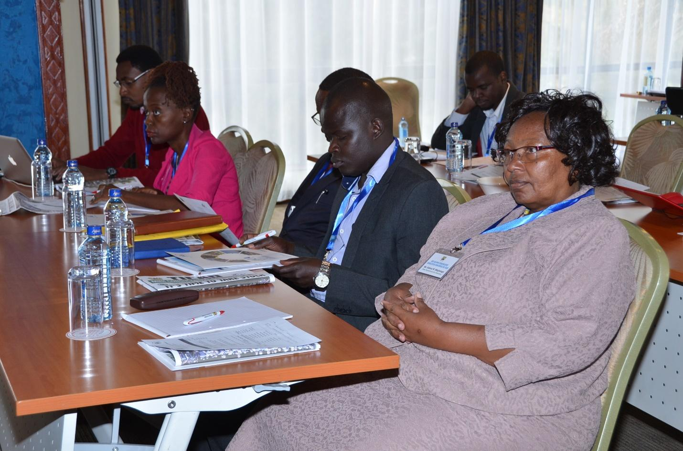
Photo 11: A Section of Participants Follow Proceedings during the Conference

TICAD and the Consolidation of the Private Sector
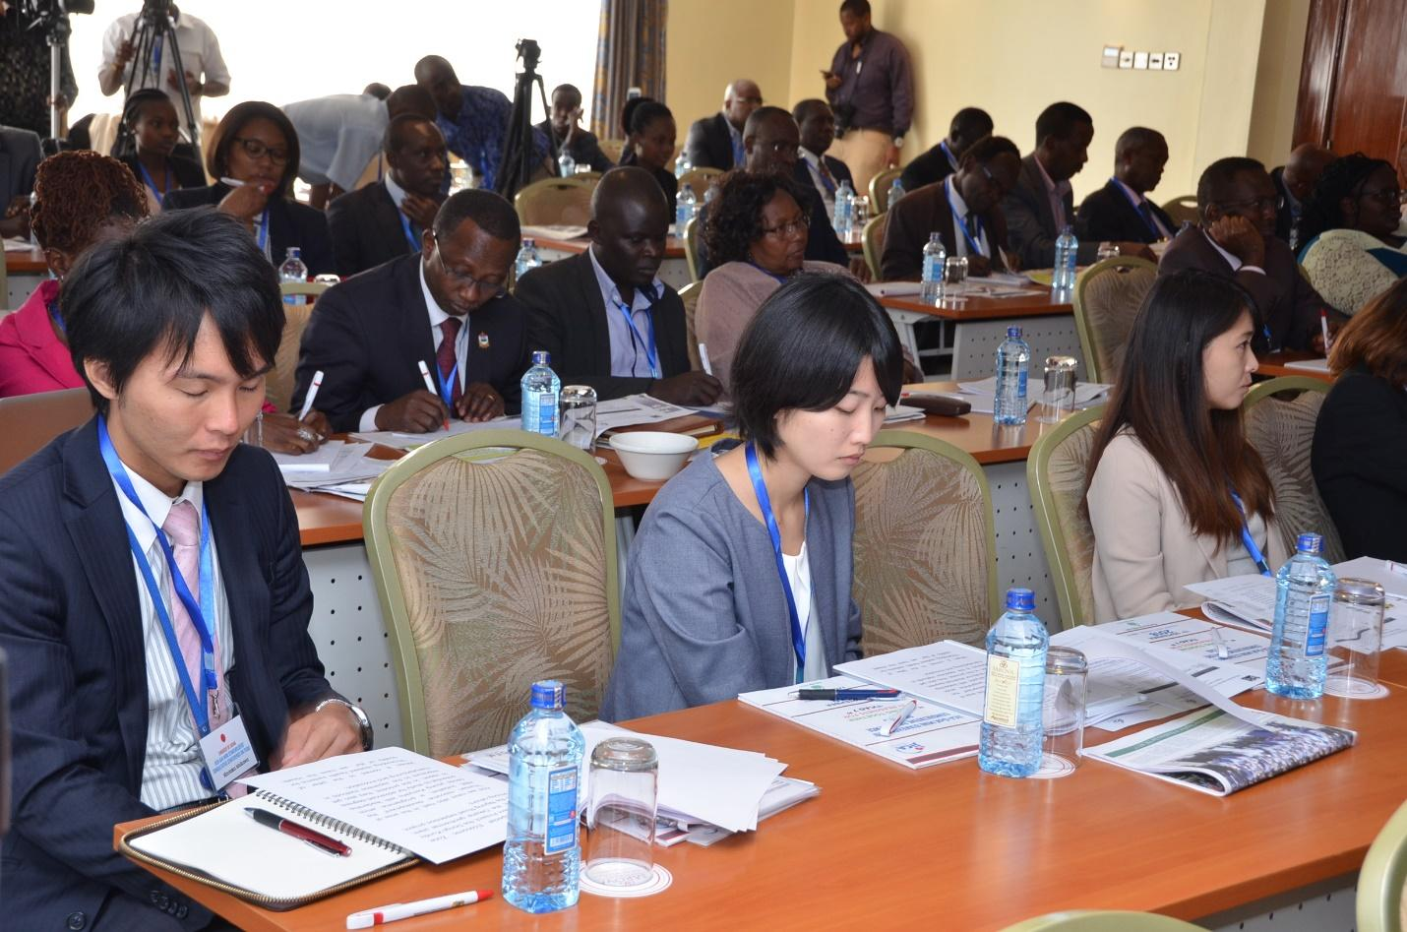
Photo 12: Participants follow proceedings during the Conference
This section session was aimed at listening and sharing on the perspectives of the private sector players in the TICAD implementation process. The presentations are as highlighted below:

Japan External Trade Organization (JETRO)
Mr. Atsuhiko Naoe, the Executive Director Naoe mentioned that JETRO is a Japanese organization that seeks to promote mutually beneficial trade and investment between Japan and other countries. Between 2014 and 2018, the number of Japanese companies investing in Kenya rose from 30 to 58. The Food and Beverage Exhibition (FOODEX) 2018 gave Kenyan companies an opportunity to showcase their products.
He stated that three Kenyan healthcare companies were also sent to Japan to learn and share with Japanese companies. Through the Trade Tie-Up Promotion Programme, business delegations from Japan seeking new partnerships in Kenya have been invited to come to the country.
He indicated that some sectors ae more advanced in Kenya than in Japan, therefore a lot of cross-learning has been taking place. Participants were encouraged to contact JETRO if they would like to be linked to do business with Japan.

Kenya Investment Authority (KenInvest)
Ms. Heather Munyao, revealed that KenInvest has been promoting investments in textiles and apparel, leather and construction materials industry. Through the African Investment Promotion Forum, JICA has offered capacity development support to KenInvest. During TICAD VI, 21 out of 73 MoU’s signed between African Countries and Japan were Kenyan. Furthermore, as stated by Mr. Naoe, Kenya has seen an increase in the number of Japanese companies investing in Kenya since TICAD VI.

Kenya Association of Manufacturers (KAM)
Mr. Reynaud Wanakacha stated that Kenya’s manufacturing sector contribution to the economy has been declining in recent years. The Big Agenda aims to increase manufacturing contribution by 15% by 2022. The priority areas under focus are as presented by KenInvest namely Agro-processing, Fish, Textiles, ICT and others. JICA can help KAM to facilitate growth in the manufacturing sector through increased investment in renewable energy and improved human capital investment in technology.

Kenya National Chamber of Commerce and Industry (KNCCI)
Ms. Caroline Cherop stated that KNCCI’s main role is in trade advocacy. That recently, KNCCI has established offices in all 47 counties through the County Empowerment Programme but needs assistance to carry out capacity building in these counties. In this regard, streamlining private sector participation is an important part of the Big 4 agenda and so far four luncheons have been held to discuss this. KNCCI has also formed a consortium with Karatina University on how private sector can take part in the Big 4 agenda. JICA support is needed to develop a document on this process. KNCCI is also working to provide markets and need capacity development support for SMEs and farmers.

Plenary Session 4
- Presenters from the private sector were asked if they have ideas on how to strengthen private sector engagement with the TICAD process.
- Over 200 Kenyan CEOs attended TICAD VI. What can we show for this?
- Presenters stated that the results of private sector engagement may come out after the next TICAD meeting.
- Can we promote Japanese or Asian SME’s with global ambition?
- Acceleration of the SEZ may provide incentive for Japanese companies to come to Kenya. Mr. Naoe stated that only 10% of SMEs work outside Japan and these is need for international-level quality which is why JETRO works with larger Kenyan companies. Growing of smaller companies can be left to donor countries. Kenya is ranked 3rd in Africa in terms of the business environment after Mauritius and Rwanda. However, income levels need to rise in order to provide a good market for Japanese companies.
- The participants also questioned the growth in number of Japanese companies investing in Kenya from 30 to 58 companies investing in Kenya between 2014 and 2018.
- KenInvest were asked which of the 21 MoU’s signed are working and what roadblocks are preventing implementation of the remaining ones.
- KAM and KenInvest were encouraged to lobby for the removal of the pre-inspection requirement of commodities from Japan to avoid delays like those experienced by Kubota Agricultural Equipment Company. Kubota were encouraged to apply for exemption from pre-inspection for example by showing their contribution to Foreign Direct Investments (FDI).
- It was stated that drastic measures are needed to attract investment to Kenya which is facing a number of issues including unemployment, poverty and low income levels. KAM was asked how they are working with the Big 4 Agenda for example in value addition productivity. KAM is currently working with JICA through its Technical and Vocational Education and Training (TVET). KAM has also engaged with government on AT zero-rating or VAT exemption of pesticides and pest control products. The KNCCI is able to deliver on strengthening private sector engagement to encourage foreign investment. A number of challenges making Kenya less investor friendly still need to be tackled including: High cost of living and resultant impacts on consumer purchasing power, and the need to show more productivity for our borrowing.

EXPECTATIONS OF TICAD VII
__________________________________________________________________
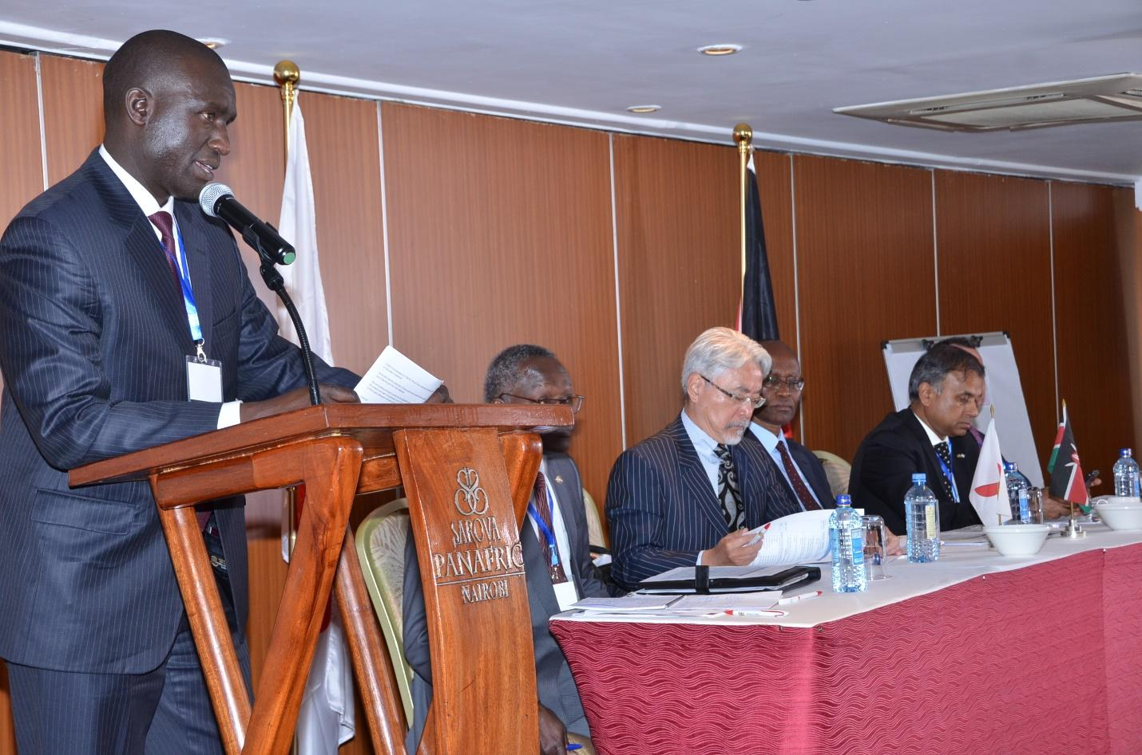
Photo 13: Mr Maina during his presentation
Mr. James Maina, the Deputy Chief Economist in the State Department for Planning summarized expectations for TICAD VII. The Kenya government currently has projects from TICAD V and VI ongoing. There is need to ensure the programmes are completed on time and with results. The 3 pillars are still relevant today. He urged the TICAD implementing partners to focus on the priority areas as captured in the three Pillars as highlighted in table 1 below.

Table 1: TICAD Implementation Strategy
No | Pillar | Component | Target
 | PILLAR 1: Promoting Structural Economic Transformation through Economic Diversification and Industrialization | Economic diversification and industrialization | - Region-wide development  - Food value chain (FVC)  - Agriculture and blue/ocean economy
 |  | Quality infrastructure | - Construct and manage quality transport infrastructure.  - Enhance and promote quality infrastructure investment by providing financing  - Promote upstream investment to exploit energy resources abundant in African countries  - Develop high quality infrastructure, which contributes both to improvement of people's daily life and promotion of tourism, such as public transport, food logistics system, water and sewerage, waste management and high speed electronic communications, by utilizing high quality, affordable and resource efficient technology.
 |  | Private sector development | - Productivity and quality standards  - Business environment, trade and investment  - Productivity and quality standards  - Productivity and quality standards
 |  | Human resource development | - Develop human resources particularly in the field of science, technology and industry, including fostering women entrepreneurs and researchers.
 |  | Public-private partnership | Establish a high level business forum between Africa and developed countries with participation from both public and private sectors.
 | Pillar 2: Promoting Resilient Health Systems for Quality of Life | Health system strengthening | - International Health Regulations IHR core capacity building - Promote implementation of the International Health Regulations (IHR) by enhancing surveillance and the capacity of laboratories  - Governance and financing - Strengthen institutional capacity for policy making, governance, management and alignment of health programmes with national health sector strategies  - Quality health service and human resource development - Promote capacity for health system management and provide disease prevention trainings  - Immunization -Increase coverage and equity of immunization to protect every child  - Addressing various diseases - Strengthen countermeasures for prevention and control of non-communicable diseases (NCDs),  - Research and development (R&D) - Improve prevention, diagnosis and treatment of infectious diseases by promoting international joint research.
 |  | Response to public health crises | - Enhance the capacity of each country to manage health emergency risks  - Enhance the global health architecture and support funding mechanisms
 |  | Universal health coverage | - Support UHC-related policy reform and develop relevant human resources by increasing the number of competent policymakers and managers in the health sector in African countries
 |  | Nutrition | - Enhance nutritional status in African countries through multi-stakeholder and multi-sector approaches, focusing on better data, by promoting the Initiative for Food and Nutrition Security in Africa (IFNA).
 | Pillar 3: Promoting Social Stability for Shared Prosperity | Social stability and peacebuilding | - Provide humanitarian and development assistance  - Support measures to prevent and respond to high incidences of sexual and gender-based violence  - Implement and scale up measures to strengthen social safety nets,  - Foster dialogue, inclusion and social cohesion  - Develop essential infrastructure such as local roads, schools and those related to ICT, which lay foundation for individuals to have access to education and livelihoods.  - Promote youth employment and women entrepreneurship,  - Introduce effective border management through holistic approaches  - Contribute to peacebuilding efforts
 |  | Terrorism and violent extremism | - Strengthen the administrative capacity of national and local government to combat terrorism, illegal trafficking, and corruption  - Strengthen capacities for cross-border surveillance and security,  - Promote dialogues, exchange of information and cooperation at the regional, continental and international levels on issues such as terrorism, proliferation of weapons of mass destruction and organized crime.  - Promote culture of peace
 |  | Global issues and challenges | - Climate change and natural disasters  - Food security
 |  | Maritime security
 |  | United Nations in the 21st century
 | Strategies for Cross Cutting Areas | - Empowering Youth, women and persons with disabilities;  - Promoting science, technology and innovation;  - Human resource development;  - Human resources development;  - Advancing public-private-Partnership
 | The TICAD allows a follow-up mechanism | - Joint Secretariat for robust monitoring and reporting  - Joint Monitoring Committee  - Follow-up meeting  - Senior officials meeting  - Ministers’ meeting

SUMMARY OF DISCUSSIONS AND KEY RECOMMENDATIONS
__________________________________________________________________
Dr. Outa on behalf of IDEA summarized the deliberations of the TICAD Mini-Conference and made the following observations:
- National Institutional Arrangements: the national Institutional and Inter-Ministerial collaboration is fairly weak and needs to be strengthened in order to take the TICAD process forward. In particular, it appeared very clear that since the end of TICAD VI back in 2016, practically all the institutions had not spoken to each other and they had not met in order to jointly review progress;
- TICAD Reporting Format: Judging from the diversity of presentations made at the Mini conference, it is clear that there is no single structured template for reporting. Going forward it would be necessary for stakeholders to discuss and agree on a reporting framework or template that can guide future reports;
- Communication, Media and Awareness creation: One key challenge in the TICAD agenda remains the lack of information in the public domain. Most Kenyans were unaware of the extensive and huge investments that Japan has been making in Kenya for a very long time. Indeed some Japan-Kenya projects were often mistaken to have been implemented by other bilateral partners. In this regard, a strong case has to be made for making communication and publicity a strategic component of the TICAD process. It was specifically recommended that going forward, an institution such as IDEA be retained in order to structure a process that would lead to more frequent exchange of information, including communication and publicity with the Kenya and other African publics.

Mr. Maina was tasked with convening the key sectors so that the TICAD stakeholders can have a clear format for reporting on progress of programmes. A framework is also needed to link what is reported with what is on the ground. Finally, he emphasized the need to strengthen private sector engagement with TICAD.
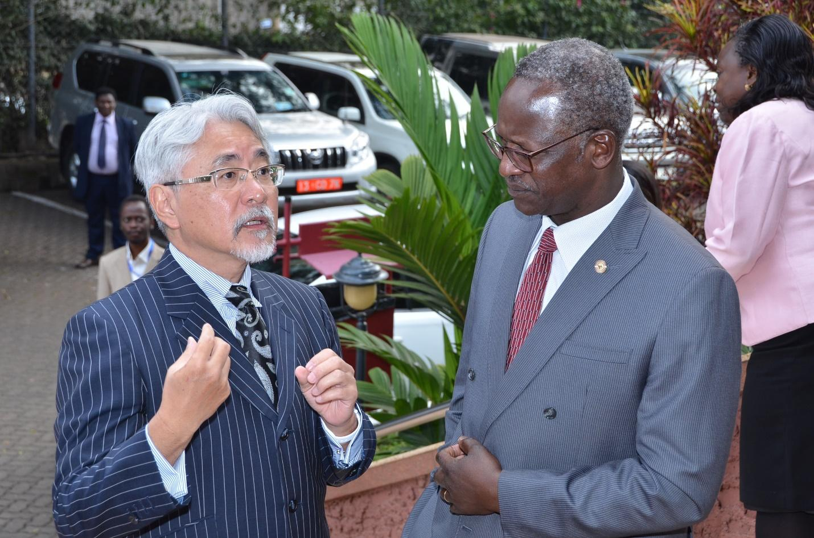
Photo 14:H.E Amb. Uesawa and Amb. Ogutu in a Consultative Moment on the Side-lines of the Conference

CLOSING REMARKS
__________________________________________________________________
The closing remarks were given by Ms. Keiko SANO, Chief Representative, Japan International Cooperation Agency (JICA)
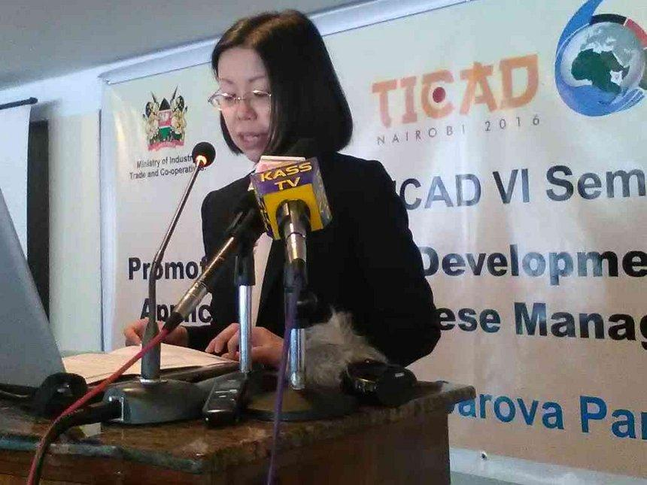
Photo 15: Ms. Keiko SANO, in a past event (Photo Courtesy of the Star News)
Speaking on behalf of Japan International Cooperation Agency, JICA, Ms Keiko SANO took the opportunity to thank all the participants, co-organizers, and the Government of Kenya for having found time to plan and attend the JICA-GoK Mini Stakeholders’ Consultative Conference on TICAD in Nairobi. She said that JICA was honoured to have co-hosted the event with the Government of Kenya, and more specifically with the State Department of Planning. She also extended her appreciation to the Embassy of Japan and TICAD Co-Organizers, namely the World Bank, UNDP and AUC for gracing this event this morning.
Ms SANO stated that the Mini-Consultative Conference demonstrated the Kenya Government’s commitment to actualizing the TICAD outcomes. She hoped that the expectations of the sensitization conference, which were (i) keeping TICAD in visibility and focus; (ii) providing and sharing current updates and (iii) adopting common positions, were adequately met.
She went further to reference that one of the rallying calls for the TICAD process is and always has been “effective implementation.” That is why TICAD has a solid follow-up mechanism with clear reporting lines, which enhances mutual accountability. She reiterated that the Mini-consultative conference supported the monitoring process and positions Kenya as a front-runner in Africa in championing the TICAD process. More so, after the TICAD VI Summit, that was held for the very first time in Africa in 2016 in Nairobi.
For this, she thanked the Institute of Development and Leadership in Africa (IDEA) for very ably facilitating the conference and for their foresight and proactive approach in bringing all actors together.
Ms. SANO recalled the rallying the conference, “Pulling Together in Readiness for TICAD VII” as a reminder on the need to collectively and consistently keep on check, the progress being made on TICAD outcomes. And especially for Kenya, the positioning of TICAD in the “Big 4 Agenda” could therefore not have come at a better time.
She went ahead to share her take on three points:
- Coordination for Ownership and Partnership: In other words, today’s workshop underscores two TICAD principles, i.e. African ownership and international partnership, and the underlying commitment of the Kenyan Government to the TICAD process through good inter-ministerial/ inter-sectoral coordination for really sustainable development.
- Private sector: She affirmed that JICA should remain committed to further accelerating growth by enhancing its catalytic role in inducing private investment in various forms of our cooperation including human resource development and productivity improvement.
- Inclusiveness: We must decisively tackle the challenges confronting us even as we strive towards achieving our targets. Sustainable development will need to be inclusive and take special care of the needs of the marginalised and most vulnerable. Strategies therefore have to be ambitious, action oriented and collaborative and must adapt to different levels of development. This is the time to act by carefully and skilfully implementing the delivery pillars and mechanisms, as well as the specific projects being undertaken in the TICAD process.
She expressed her sincere hope that the summary of the discussions will provide a good and solid base for Kenya’s position and preparations for the upcoming TICAD Ministerial Meeting in Tokyo in October. That the outcome of the deliberations will go a long way in strengthening the development path charted under the three TICAD broad pillars of Economic Transformation for Africa’s growth and promoting Human Security and Resilient Society.
Lastly, she was eager to have learnt a lot from the Mini-conference, especially Q&A sessions regarding Kenya-Japan cooperation activities so far and in future. She voiced her gratitude to the State Department of Planning and IDEA for the hard work put in organizing the conference.
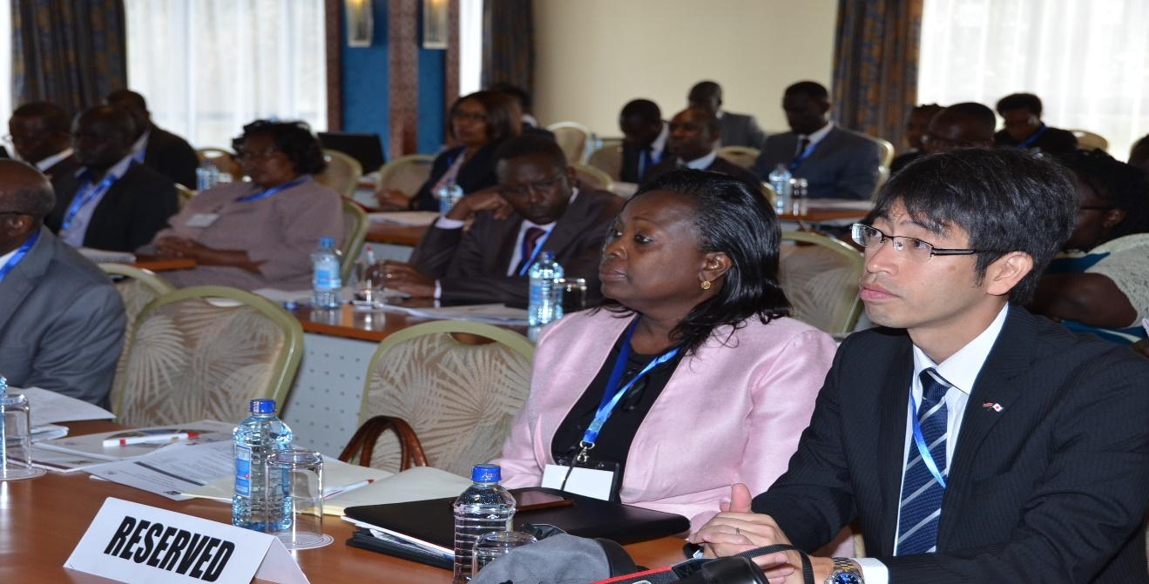
Photo 16: A section of Participants Follow Proceedings during the Conference

APPENDICES
__________________________________________________________________

Statements
The copies can be obtained from IDEA

Programme and Agenda
PROGRAMME FOR THE TICAD MINI CONSULTATIVE CONFERENCE
“Pulling Together in Readiness for TICAD VII”
Panafric Hotel-Nairobi Kenya

11th September 2018

Time | Session | Facilitator
7.45am – 8.45am | Arrival and registration of Participants | Conference secretariat
SESSION 1: | OPENING CEREMONY
8.45 – 10.00 | - Welcoming Remarks  - Highlight of TICAD VI Nairobi Declaration by Ambassador Ben OGUTU of MFA  - Statements from representatives of TICAD Co-organizers: UNDP; World Bank; African Union; UNOSSA.  - Statement by H.E Amb. Uesawa, Japan Ambassador to Kenya  - Key Note address by PS, State Department of Planning | Dr. George Outa
10.00 – 10.15 | Health Break And Photo Session
Time | Session 2: STATUS OF TICAD IMPLEMENTATION | Moderator
10.15 – 11.15 | - Sub-Theme 1. TICAD and Economic Growth:  - Energy Mr. Patrick Irungu  - Trade Mr. Bramah Kaleve  - Transport Mr. George Wanjau  - Infrastructure Mr. Boniface Maithya  - Industrialization Mr. Stephen Odua  - Blue Economy Mr. Betty Nyonje  - Tourism Mr. David Kinyangi | Department of Planning
11.15 – 11.40 | Plenary
11.40- 12.25 | Sub-Theme 2: TICAD and Agricultural Development:  - Crop development Ms. Florence Malenge  - Water Eng. Isaac Kimani  - Irrigation Mr. Phanuel Webi  - Fisheries Mr. Joseph Katumo  - Livestock  - Research Dr. Oscar Magenya | Dr. George Outa
12.25-12. 45 | Plenary
12.45-13-45 | Lunch Break
13.45-14-15 | Sub-Theme 3: TICAD and Social Transformation:  - Health  - Basic Education Ms. Loise Macharia  - TVET Ms. Evelyne Anupi | State Department of Planning
14.15-14.35 | Plenary
14.40-15.10 | Sub-Theme 4: TICAD and the Inclusive Society Agenda (Security and Climate Change counter measures):  - Security Mr. Joseph Macharia  Mr. Hosman Jesore  - Social Protection  - Climate Change Mr. Mwendandu
15.10-15.30 | Plenary
 | STATUS OF TICAD IMPLEMENTATION
15.30- 16.00 | TICAD and the Consolidation of the Private Sector:  - JETRO Mr. Atsuhiko Naoe  - KenInvest Ms. Heather Munyao  - KAM Mr. Tobias Alando  (Ag. CEO)  - KEPSA Mr. Timothy Odongo  - KNCCI Mr. George Kiondo  (Ag. CEO) | Ambassador Chika of MFA
16.00-16.10 | Plenary
16.10-16.20 | TICAD in Kenya’s ‘BIG 4 Agenda:  - Office of the President
16.20-16.30 | Expectations of TICAD VII:  - State Department of Planning
16.30-17.00 | Summary of the Discussions | Dr. Outa, IDEA
 | - Closing Remarks | JICA

List of Delegates and Participants
 | Name of Participant | Organization | Email
 | Eng. Isaac Kimani | Ministry of Water and Sanitation | isaacgichui@gmail.com
 | Mr. Robert Gatonga | National Treasury | rwgatonga@gmail.com
 | Mr. Boniface Maithya | State Department for Infrastructure | bonifacemukuli@gmail.com
 | Mr. Richard Mwendandu | Ministry of Environment and Forestry | rj.mwendandu@yahoo.com
 | Ms. Loise Macharia | State Department for Early Childhood and Basic Education | loicekim80@gmail.com
 | Mr. Bramah Kaleve | State Department for Trade | kbramah@gmail.com
 | Carolline Kosiom | KNCCI | carolinekosiom@kenyachamber.or.ke
 | Mr. Reinhard Wanakacha | KAM | reinhard.wanakacha@kam.co.ke
 | Mr. Joseph Macharia | Interior | jomacharia@gmail.com
 | Mr. Hosman Jesore | Interior | hkchesaro@gmail.com
 | Phanuel Webi | State Department for Irrigation | webiphanuel@yahoo.com
 | Betty Nyonje | Blue Economy
 | Dr. Peace Masinde | Ministry of Health | peacemutuma@yahoo.com
 | Pius Fundi | KiTN | fundipius@gmail.com
 | Heather Munyao | KenInvest | munyao@investmentkenya.com
 | Simon Githaiga | KAA | simon.githaiga@kaa.go.ke
 | Johan Mistiaen | World Bank | jmistiaen@worldbank.org
 | Stephen Kioko | State Department for Crops | skmuthini@gmail.com
 | Mohamed Seisy | AU-IBAR | mohamed.seisy@au-aibar.org
 | Florence Syeruo | CCFA | flosyeruo@gmail.com
 | Julius Chokarah | UNDP Kenya
 | Patrick Ochieng | MAOLAF | okakapoto@yahoo.com
 | Paul Kingori | MOTIHUD | kingoripkk@gmail.com
 | Roger Dhhways | UNDP | roger.dhhway@undp.org
 | Prof. Ahmed Abdul | African Union
 | Eric Opiyo | GoK
 | Fidelma Opiyo | GoK
 | Nicholas Nthenge | GoK
 | Samuel Mwangi | MOITC | sakibo2009@gmail.com
 | Naoe Atsuhiko | JETRO
 | Mr. Joshua Opiyo | SDP | joshuaopiyo1@yahoo.com
 | Mr. James Maina | SDP | mainakiumu@gmail.com
 | Ms. Sabina W. Maghanga | SDP | sabinamaghanga@gmail.com
SECRETARIAT
 | Mary Ndana | SDP | ndanama@yahoo.com
 | Elizabeth Ndami | SDP | lizndamiwa@yahoo.com
 | David Atwoli | SDP | davidchukwa@gmail.com
 | Isaiah Ndunda | SDP | isaido@gmail.com
MINISTRY OF FOREIGN AFFAIRS

 | Amb. Benson Ogutu | MFA
 | Amb. Christopher Chika | MFA
 | Dr. George Outa | MFA
 | Mr. Lindsey Kiptiness | MFA | Lindsey.kiptiness@gmail.com
 | Mr. David Gatuthe | MFA | dgatuthe@mfa.go.ke
 | Robert Mokaya | MFA | danmokaya81@gmail.com
IDEA
 | Mr. Denise A. O. Kodhe | IDEA | denise.kodhe@ideaforafrica.org
 | Ambassador Zaddock M. Syongo’h | IDEA | zsyongoh@iracc.co.ke
 | Dr. George Outa | IDEA | georgeouta@ideaforafrica.org
 | Prof. William Ogara | IDEA | wogara@uonbi.ac.ke
 | Dr. Amolo Mbole | IDEA | lambole@uonbi.ac.ke
RAPPORTEURS
 | Jacob Olonde- | IDEA | olondejacob@gmail.com
 | Dinah Ogara | IDEA | dinah.ajwah@yahoo.com
 | Yvonne Githiora | IDEA | y.githiora@gmail.com
 | Vincent Ondieki | IDEA | vincentndkz@gmail.com
 | Rose Muthoni | IDEA | rosemuthoni2011@gmail.com
JICA

 | Ms Ann Olubendi | JICA | Anneolubendi.ky@jica.go.jp
 | Mr.Miyagawa Masahito | JICA | Miyagawa. Masahito@jica.go.jp
 | Mary Ann Kimani | JICA | kimanimaryann.ky@jica.go.jp
 | Shoko Isokawa | JICA | Okawa shoko@jica.go.jp
 | Caroline Nzioka | JICA | nzioka-caroline@jica.go.jp
60 Beryl Otieno JICA otienoberyl.ky@jica.go.jp

EMBASSY OF JAPAN

 | Yui Takashima | EOJ | yui.takashima@mofa.go.jp
 | Hiroko Atarashi | EOJ | hiroko.atarashi@mofa.go.jp
 | Rika Karikomi |  | rika.karikomi@gmail.com
 | Hirotaka Ishikawa | EOJ | hiroka.ishikawa-2@mofa.go.jp
 | Seiji Tashiro | EOJ
PRESS

 | Onyango Omolo | Liberal Tribune | onyamolo@yahoo.com
 | Wanjiku Kimani | KTN | kimaniwanjiku@gmail.com
 | John Kariuki | Kameme | j.kariuki85@gmail.com
 | Lynet Igadwah | NMG | linigad2@gmail.com
 | Ken Bosire | People Daily | ken.bosire@mediamax.co.ke
 | Salaton Nja | NMG | salatonja@gmail.com
 | Simon Muli | Asian Weekly
MEDIA

 | Mohamed Ali | KNA | moheralia@gmail.com
 | Denis Wafula | KNA | deniswafula820@gmail.com
 | Joshua Ngenga | KNA | joshuangenga58@gmail.com
 | Mr. Mark Gikonyo | TICAD Special Edition | mark.gikonyo@gmail.com

Workshop Presentation and Handouts

